2nd Lab

**Put in Introduction, Methodology, Discussion of Results, Conclusions for Each Part and Matlab code if applicable and do in said order**

**Part 1. Poisson Distribution Using disttool**

For lambda = 1, make linear and 10 * log10 plots for both the pdf and cdf as follows for X = 0 to 10 in increments of 1:

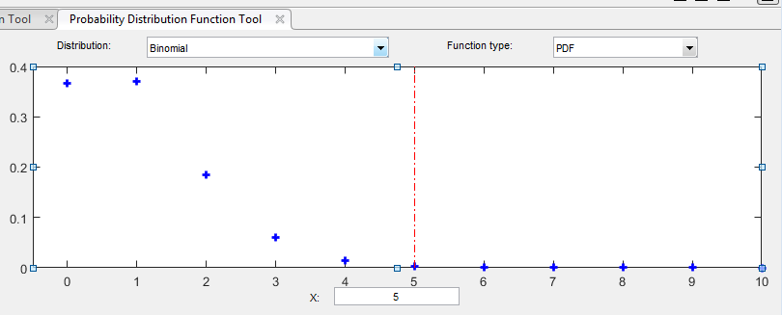

Label the Disttool files. Get plot of detail from x =0 to x=10

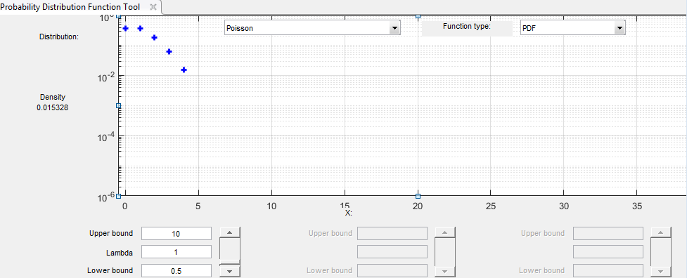

Label the Disttool files. Can you get plot of detail from x =0 to x=35?

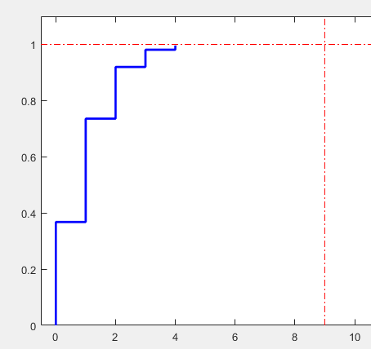

CDF. Label the Disttool files. Plot this from x =0 to x=10

>>>>>>>>>>>>>>>>>>>>>>>>>>>>>

Part 2. Use Your own MATLAB script to do what you did in Part 1, except in ML Script. **In general more credit for labeling your MATLAB curves in detail**

For example here is mine and write your own

clear all;

close all;

clc;

x=0:1:10;

p = poisspdf(x,1)

% this built in function for Poisson distribution

figure (1)

plot(x,p,'*')

grid on

figure (2)

semilogy(x,p,'*')

grid on

>>>>>>>>>>>>>>>>>>

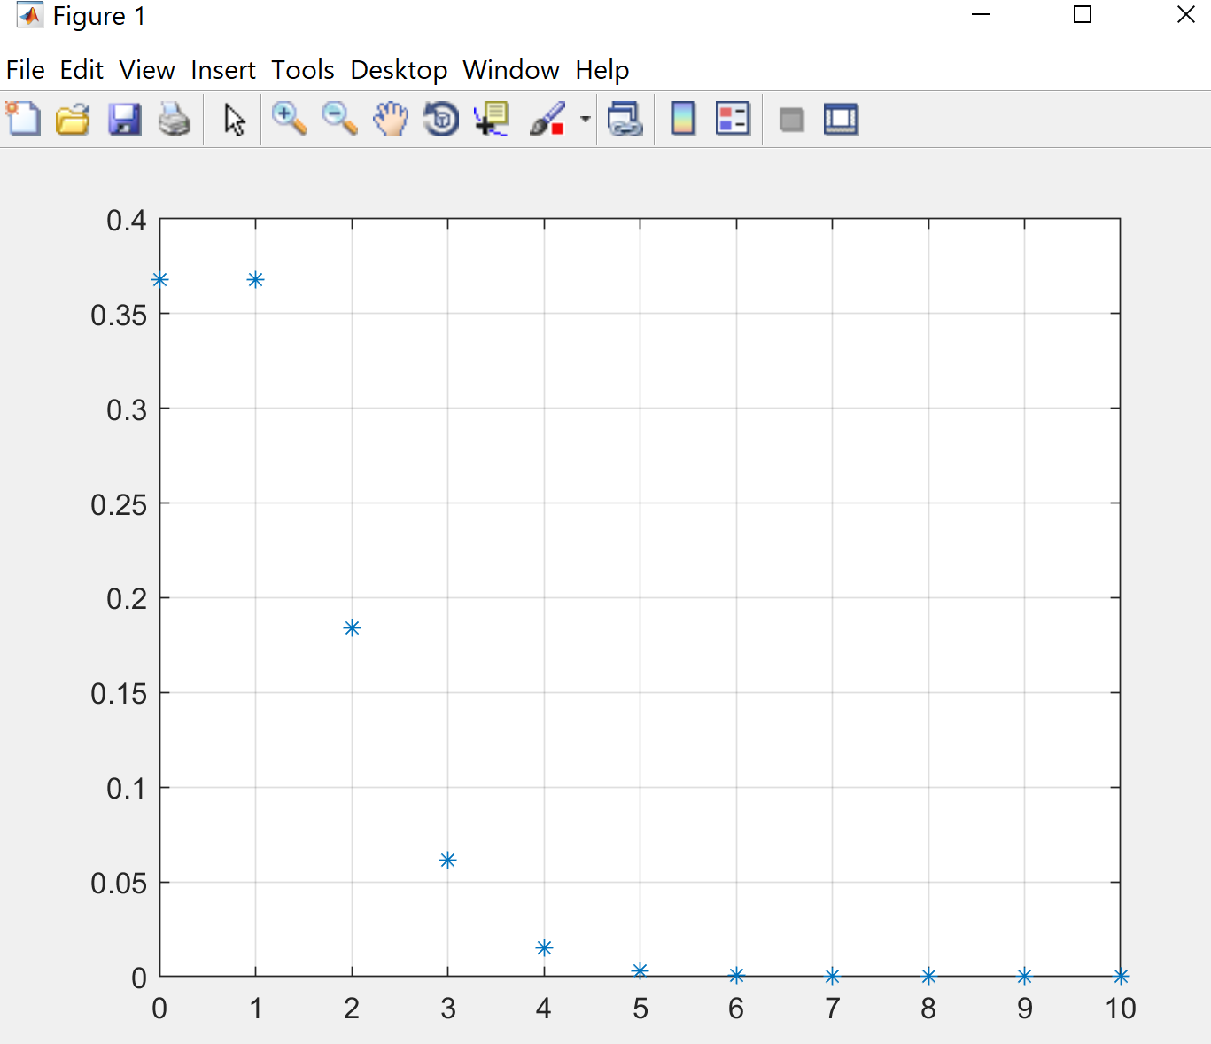

Label this graph in detail.

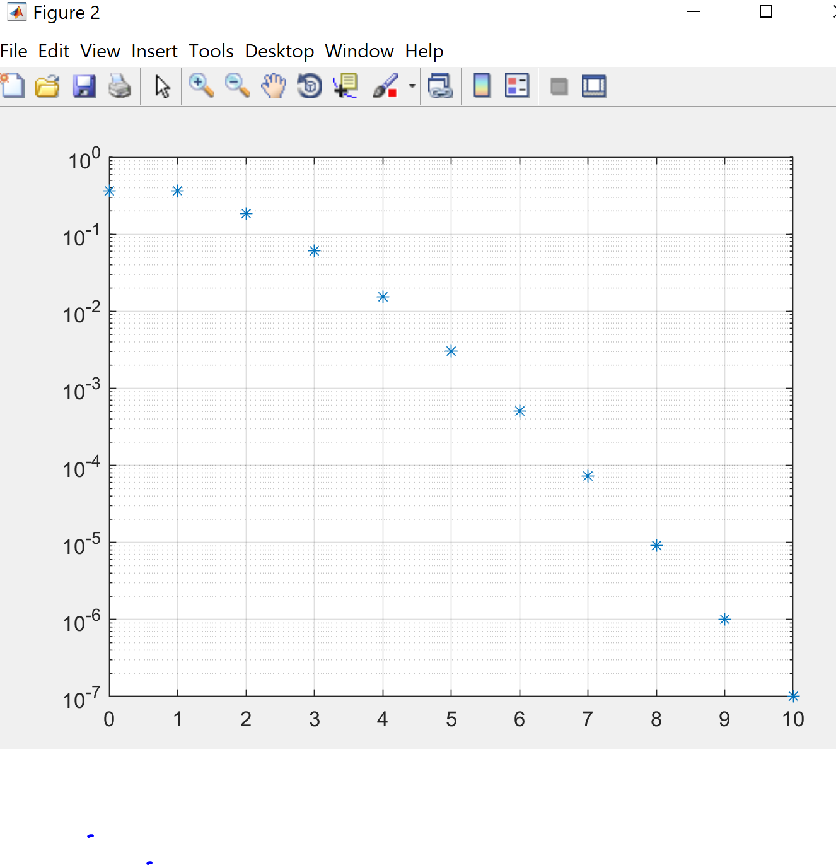

For x =6 to x=10, why is the curve approaching a straight line

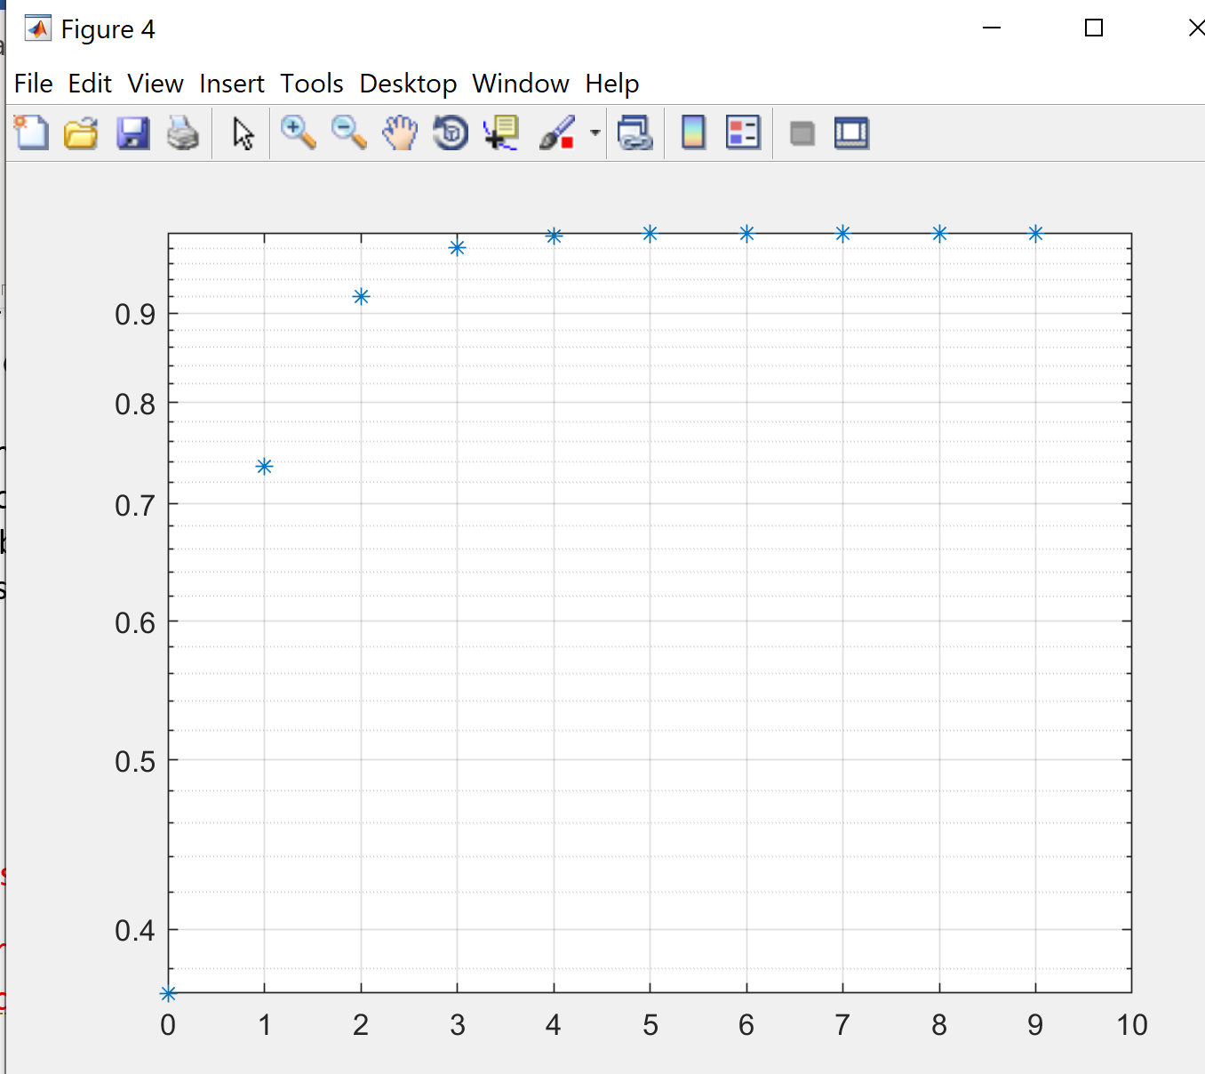

Label this graph in detail and also create in stair case not like the above.

Write the ML S/W for the cdf and plot from x=0 to x=10.

>>>>>>>>>>>>>>>>>>>>>>>>>>>>>>>>>>>>>>>>>>>>>>>>>>>>>>>>>

**Part 3 Relation Between the Binomial and Poisson Distributions (6 ML plots) Rare Event.**

Let for Binomial Dist n=100 and p=.01 so that np=1 =lambda.

Give THE theory for rare event.

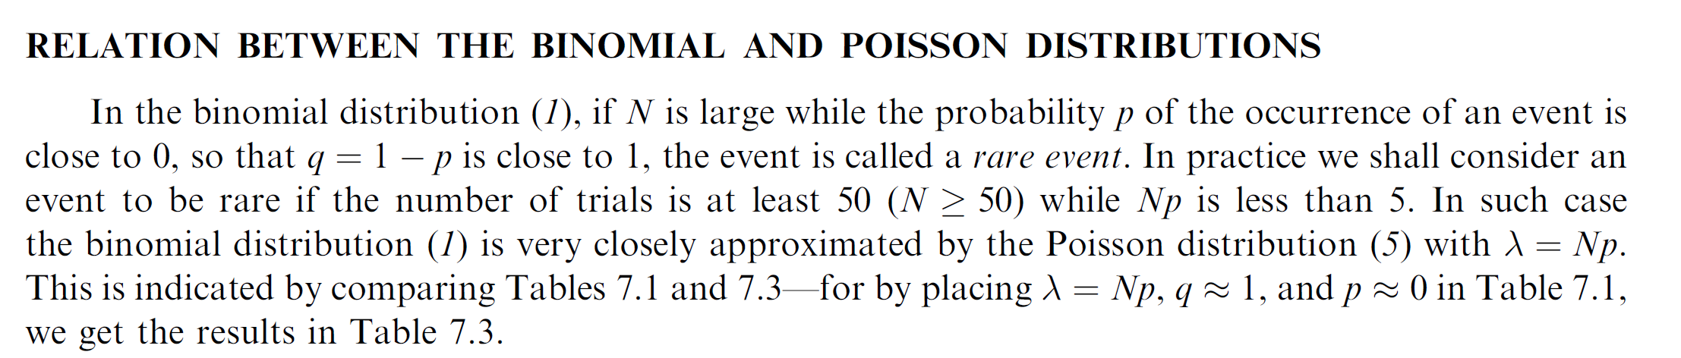

1. Plot the pdf and cdf for binomial Dist. (2 plots) and the Poisson (2 plots) using for x = 0 to 10 in increments of 1 for linear curves for:
2. Using your own MATLAB code and here also compare on a single curve the Poisson versus the Binomial distribution for (a) the pdfs and (b) the cdfs. Label graphs in detail.

**Part ~~4~~: Extra Credit**

For Poisson Distribution withy lambda =1, make linear and 10*log10 plots for both the pdf and cdf as follows for X=0 to 10 in increments of 1:

1. Extra credit if you use C language or C++ (Four times as much extra credit for doing in C++)
2. Extra credit if you use Python language
3. Do in excel
4. Do in Mathematic
5. Do Minitab

Appendix: Some example of ML code. You can write your own version.

Backup Information ML Code 1

clear all;

close all;

clc;

lambda =1

x=0:1:10;

p=(lambda.^x).*exp(-lambda)./factorial(x)

a= (lambda.^x)

b=exp(-lambda)

factorial(x)

figure (1)

plot(x,p,'*')

grid on

figure (2)

semilogy(x,p,'*')

Backup Information ML Code 2

clear all;

close all;

clc;

x=0:1:10

p=.01

n=100

y = binopdf(x,n,p)

figure (1)

plot(x,y,'*')

grid on

figure (2)

x=0:1:10;

lambda=p*n

pp=(lambda.^x).*exp(-lambda)./factorial(x);

factorial(x);

plot(x,pp,'*')

grid on

%%%%%%%%%%%%%%%%%%%%%%%%%%%%%

figure (3)

x=0:1:10

p=.01

n=100

y = binopdf(x,n,p)

plot(x,y,'*')

grid

hold on

x=0:1:10;

lambda=p*n

pp=(lambda.^x).*exp(-lambda)./factorial(x);

a= (lambda.^x);

b=exp(-lambda);

factorial(x);

plot(x,pp,'sr')

grid on

figure (4)

semilogy(x,pp,'*')

grid on